Issues on WFP Resilience Interventions in Chad, 2018-2023 datasets
This report presents the inconsistencies and gaps in ten rounds of household survey data collected in Chad from 2018 to 2023. Inconsistencies are subdivided into three levels: administrative issues, variables recodification and intervention variables gaps/incompleteness.
- Issues on administrative variables
In this section we present the gaps in administrative variables:
- The second administrative variable (department) is missing for third round (PDM 2020) in the dataset. We use village information to fill in the department information.
- There are also some villages that could not find the right department or region.
These gaps/inconsistencies introduce significant challenges for harmonization. For more information including gaps and inconsistencies please refer to this link https://bookdown.org/aboubacarhema94/WFP_Chad_Cost_Benefit_Analysis_data_merging/

- Issues on variables recodification
Another challenge in harmonizing the 10 rounds is the recording of the variable modalities. There was a great deal of inconsistency in the recording from one survey to another and from one year to another. For instance, the variable "Vente des biens non productifs (ex. mobilier, bijoux, etc.)" was intended to be coded as follows:
- Non, je n'ai pas été confronté à une insuffisance de nourriture
- Non, parce que j'ai déjà vendu ces actifs
- Oui
- Non applicable
While current visualization of the variable "Vente des biens non productifs" (shown in the figure below) presents several interpretive issues. It combines numeric codes (2, 3, 4) with partial verbal labels such as "Oui" and "Non" without offering full contextual definitions for each response. Additionally, the absence of descriptive text for numeric values further obscures their meaning. Finally, the inconsistent use of both numeric and verbal labels within the same variable introduces confusion and increases the risk of misinterpretation.
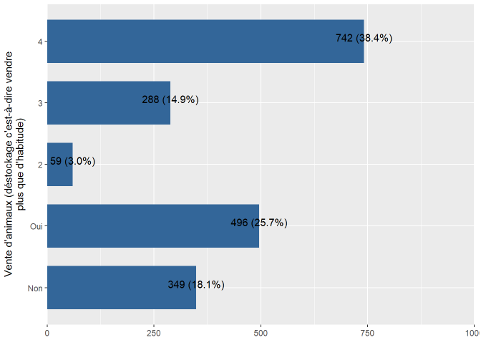
Figure 1: Example issue on WFP 2018 resilience dataset
At the same time, other variables have no description of their modalities but are coded in numeric form (Figure 2). The visualization of the variable "5.2.04 Vente d’animaux (déstockage c’est-à-dire vendre plus que d’habitude)" uses numeric codes (1–4) without providing the necessary descriptive labels for each modality.
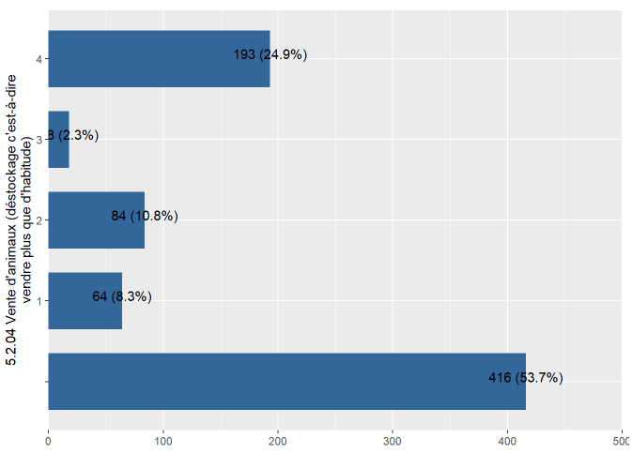
Figure 2: Example issue on WFP 2019 resilience dataset
This variable (Figure 3) was intended to have values from 0 to 7, but we have only one value (1).

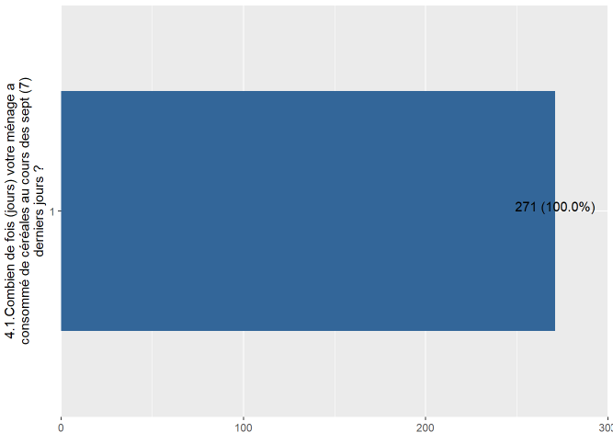
Figure 3: Example issue on WFP 2020 (PDM) resilience dataset
- Issues on assistance variables
A notable issue observed in the assistance-related variables across the ten survey rounds is the inconsistency and incompleteness of variable availability. Several key variables are entirely absent in earlier rounds and only consistently appear in the later ones. In addition, we notice inconsistencies in terms of variables modalities recodification as mentioned above. The table below gives an overview of WFP intervention variables incompleteness.
Table 1: Overview of WFP intervention variables incompleteness
Variable Name | 2018 (Baseline) – no intervention | Round 2 | Round 3 | Round 4 | Round 5 | Round 6 | Round 7 | Round 8 | Round 9 | Round 10
BanqueCerealiere |  |  |  |  |  | ✔️ | ✔️ | ✔️ | ✔️ | ✔️
VivreContreTravail |  |  |  |  |  | ✔️ | ✔️ | ✔️ | ✔️ | ✔️
ArgentContreTravail |  | ✔️ | ✔️ | ✔️ | ✔️ | ✔️ | ✔️ | ✔️ | ✔️ | ✔️
DistribVivresSoudure |  |  |  |  |  | ✔️ | ✔️ | ✔️ | ✔️ | ✔️
DistribArgentSoudure |  |  |  |  |  | ✔️ | ✔️ | ✔️ | ✔️ | ✔️
DistribVivresArgentSoudure |  | ✔️ | ✔️ | ✔️ | ✔️ | ✔️
BoursesAdo |  |  |  |  |  | ✔️ | ✔️ | ✔️ | ✔️ | ✔️
CantineScolaireBoursesAdo |  |  | ✔️ |  |  | ✔️ | ✔️ | ✔️ | ✔️ | ✔️
BlanketFeedingChildren |  |  |  |  |  | ✔️ | ✔️ | ✔️ | ✔️ | ✔️
BlanketFeedingWomen |  |  |  |  |  | ✔️ | ✔️ | ✔️ | ✔️ | ✔️
BlanketFeedingChildrenWomen |  | ✔️ | ✔️ | ✔️ | ✔️ | ✔️
MAMMASChildrenMAMPLWomen |  | ✔️ | ✔️ | ✔️ | ✔️ | ✔️
MAMChildren |  |  |  |  |  | ✔️ | ✔️ | ✔️ | ✔️ | ✔️
MASChildren |  |  |  |  |  | ✔️ | ✔️ | ✔️ | ✔️ | ✔️
MAMPLWomen |  |  |  |  |  | ✔️ | ✔️ | ✔️ | ✔️ | ✔️
FARNcommunaut |  |  | ✔️ | ✔️ | ✔️ | ✔️ | ✔️ | ✔️ | ✔️ | ✔️
FormationRenfCapacite |  | ✔️ |  |  | ✔️ | ✔️ | ✔️ | ✔️ | ✔️ | ✔️
CashTransfert |  |  |  |  |  | ✔️ | ✔️ | ✔️ | ✔️ | ✔️
CantineScolaire |  | ✔️ |  | ✔️ | ✔️ | ✔️ | ✔️ | ✔️ | ✔️ | ✔️
AutreTransferts |  |  |  |  |  | ✔️ | ✔️ | ✔️ | ✔️ | ✔️

